Problem Set 1: Single population Dynamics

Katja Della Libera

## Density-independent vs density-dependent population growth

*Discuss density-independent and density-dependent population growth. What is different about the growth rate in both cases? For population- (or density, remember that for fixed area these are equivalent) dependent growth, explain positive and negative versions in terms of the dependence of the growth rate on population size. Describe a brief biological or ecological scenario in which you might expect to find positive and negative density dependence.*

When talking about density-independent and density-dependent growth, we usually talk about the per capita growth (although we could imagine a density-independent absolute growth rate in a not locally reproducing population where only immigration and emigration influence the population). A classic example of density-independent growth rate would be the exponential model and a classic example of density-dependent growth would be the logistic model. The biological explanation for the decreasing per capita growth rate as the population approaches carrying capacity in the logistic model is the increasing competition. An ecological scenario where the relationship between the population size and growth rate is positive would be one where there is a benefit of group living such as increased ability to find mates or predator protection. Some models will have both a positive and negative relationship between population size and per capita growth, such as the Allee model, which is based on the idea that the cost-benefits of group lifting change in a non-linear way with group size. See figure 1 for examples.

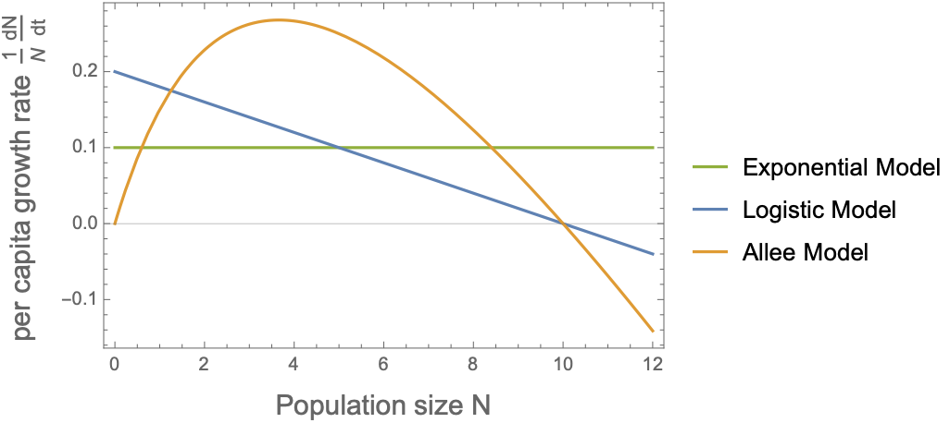

***Figure 1:*** *A plot showing density-independent exponential growth, negative density-dependent logistic growth, and both positive and negative density-dependence in the Allee Model.*

## Per Capita Growth rate and the Allee effect

*Plot the per capita growth rates of the logistic and Allee effect models on the same graph (i.e., show $\frac{1}{N}\frac{dN}{dt}$ as a function of $N$.*

*On an adjacent plot, show the respective population growth rates. Assume the models share the same nontrivial equilibrium and set $u=r=2, c=0.1$, and $v=5$.*

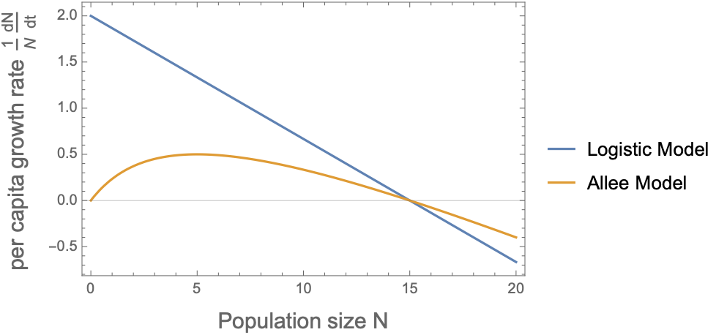

***Figure 2:***  *per capita growth rate of logistic growth model and Allee effect growth model with the same non-trivial equilibrium at $N^{*}=15$.*

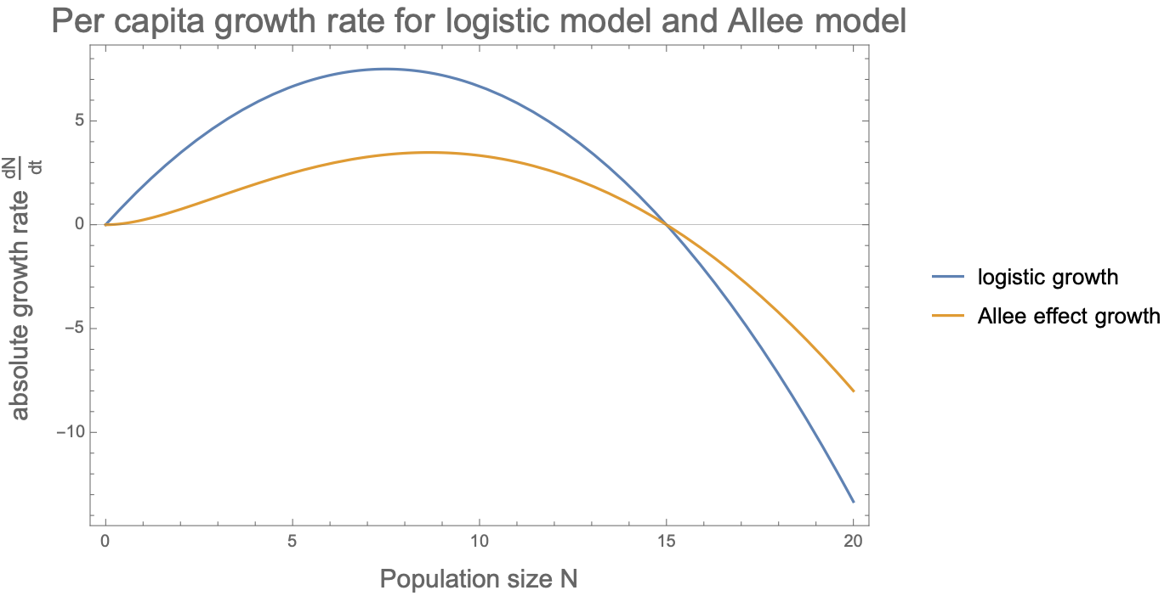

***Figure 3:*** *absolute growth rate for the same models as in figure 2.*

As expected from the non-trivial equilibrium shared by both models, the per capita and absolute growth rates reach 0 at $N^{*}=\frac{u}{c}-v=15$.

To find the maximum absolute growth rate for each model, we can look at where the derivative of $\frac{dN}{dt}$ with respect to $N$ is zero, then evaluate $\frac{dN}{dt}$ at that point. For logistic growth this is $N^{*}/2=7.5$, when $\frac{dN}{dt}=7.5$. For the Allee model, this occurs at $N=8.66$ and the absolute growth rate here is 3.48.

The per capita growth rate of the logistic model is a linear function of group size and thus maximal as N approaches 0, where it is $r=2$. For the Allee model we can repeat the process for the absolute growth rate and set the derivative of $D[\frac{1}{N}\frac{dN}{dt}]=0$*.* The per capita growth rate of the Allee model is maximized at $n=v=5$ and is 0.5.

The Allee effect describes a phenomenon where the growth rate at very low densities is low, due to difficulty of finding mates, food, or other effects based on a suboptimal group size. This is not the case in the logistic model, because the per capita growth rate here is the highest when the population is the smallest.

## Exercise 6: the Ricker model

*Repeat the analysis of the fixed point for the Ricker model*

$N_{t+1}=rN_{t}e^{-bN_{t}}$

First, we find candidate solution for $N^{*}$, where $N_{t+1}=N_{t}=N^{*}$.

$N^{*}=rN^{*}e^{-bN^{*}}$

The two fixed points are ${N_{1}}^{*}=0$ and ${N_{2}}^{*}=-\frac{log(1/r)}{b}$

Then we find the derivative of the Ricker model with respect to $N$.

$f'(N)=\frac{d}{dN}rNe^{-bN}=re^{-bN}-rNbe^{-bN}$

We try the two fixed points:

$f'(N)|_{{N_{1}}^{*}=0}=r$

This means the equilibrium is stable if $r<1$.

We repeat with the second equilibrium point

$f'(N)|_{{N_{2}}^{*}=-\frac{log(1/r)}{b}}=1+log(1/r)$

We can solve for | and get $1<r<e^{2}$

When $r=1$ both equilibria are the same, which is a transcritical bifurcation.

Next, we find non-trivial period-2-points where $N_{t+2}=f(N_{t+1})=f(f(N_{t}))=f^{(2)}(N_{t})$

$N=f(f(N))=rf(N)e^{-bf(N)}=rrNe^{-bN^{}}e^{-brNe^{-bN}}=r^{2}Ne^{-b{N(1+re^{-bN})}^{}}$

This does not have an analytical solution but we can find the numeric ones which allows us to draw the bifurcation diagram.

*And draw the bifurcation diagram.*

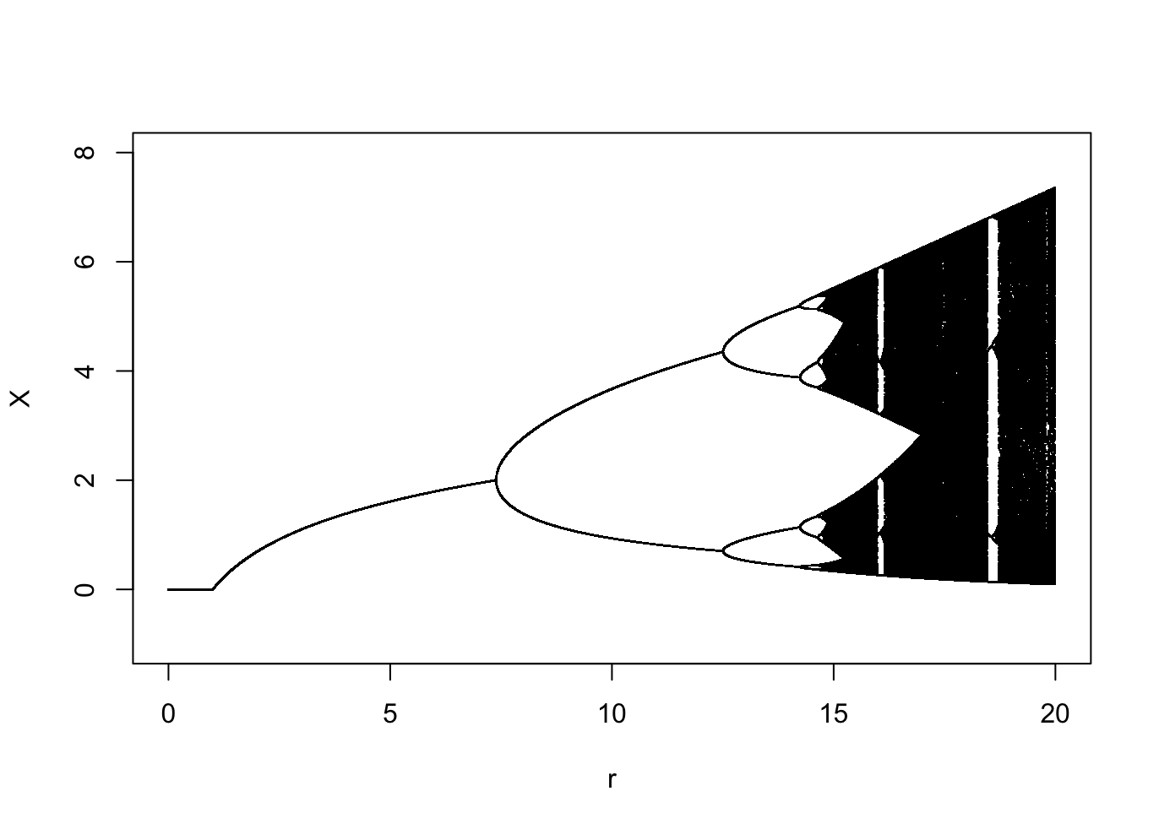

***Figure 4:*** *the Bifurcation diagram for the Ricker model when d=1. We can see the fixed point equilibrium from $1$ to $e^{2}$. And chaos when r is large.*

## Exercise 7: Numerical Integration

*Integrate the exponential growth*

$\frac{dN}{dt}=λN$

*And the logistic growth*

$\frac{dN}{dt}=λN(1-N)$

*Using as initial condition $t=0,N(0)=0.25$ until $t=10$. Plot the error at time $t=10$ as a function of the step-size (using $Δt$ =(0.05,0.1,0.2)).*

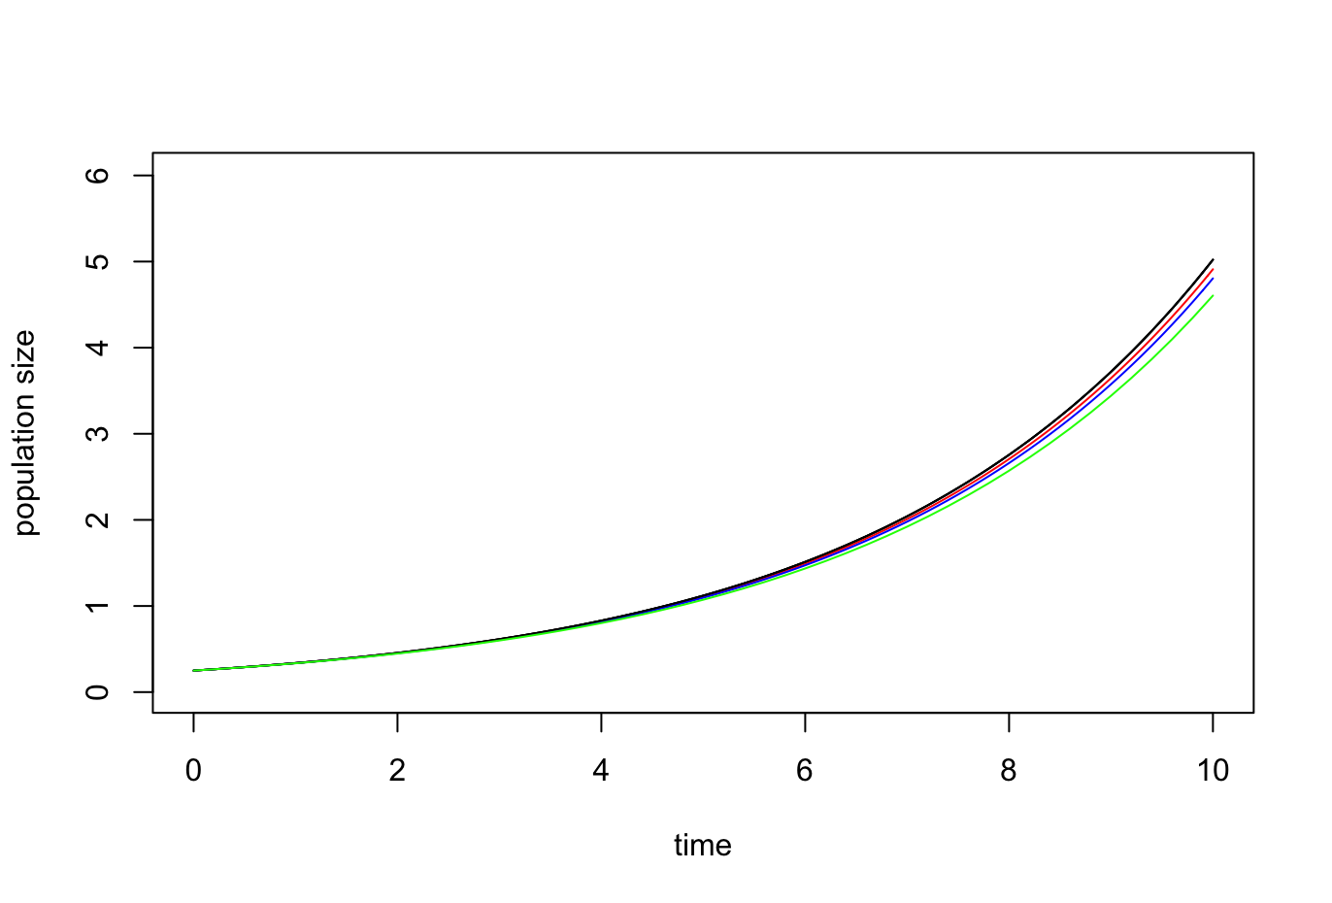

***Figure 5:*** *the estimated growth using different step size values*

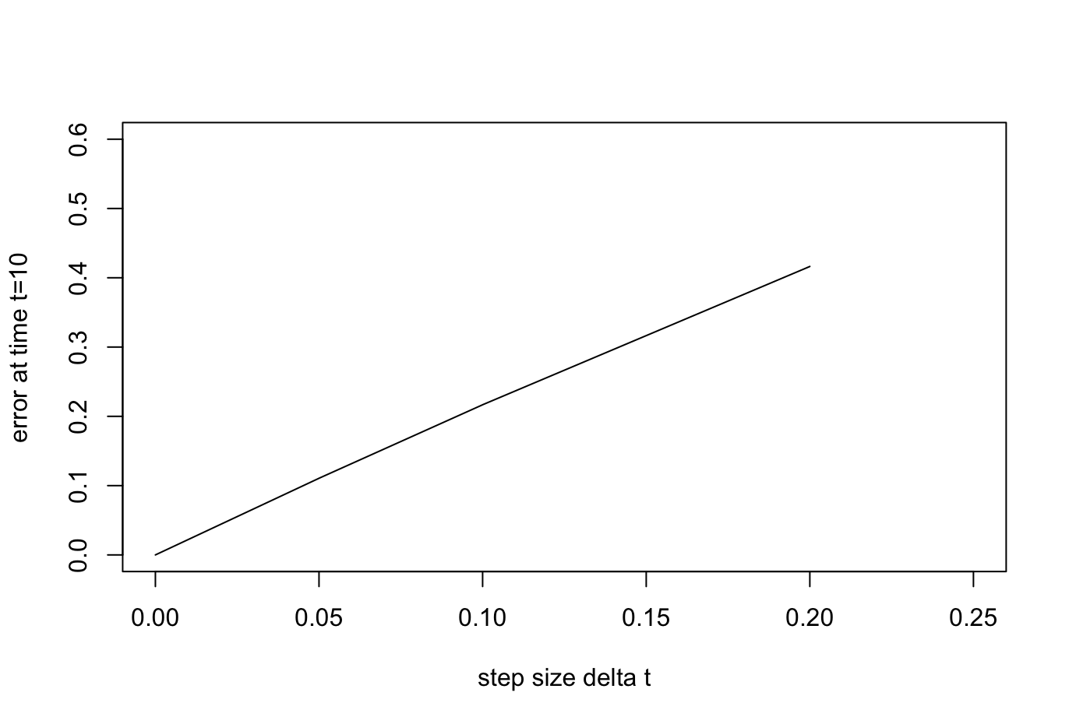

***Figure 6:*** *The error as a function of the step size increases linearly when using Euler’s method on the exponential growth function*

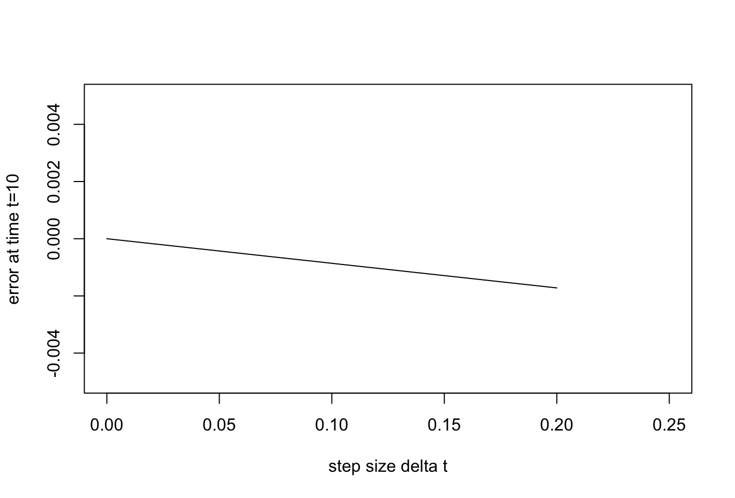

***Figure 7:*** *The error as a function of step size for the logistic growth function decreases linearly but is two orders of magnitude smaller than for the exponential growth. Even with the 0.2 step size the error is just -0.0017200739.*

## Exercise 8: More numerical integration

*Integrate the exponential, logistic, Allee, Levins, and theta-logisitic ODE models using deSolve and plot the dynamics over time.*

Since the exponential, logistic, Allee and Theta-logistic model work with absolute population size, we can plot them all on the same plot:

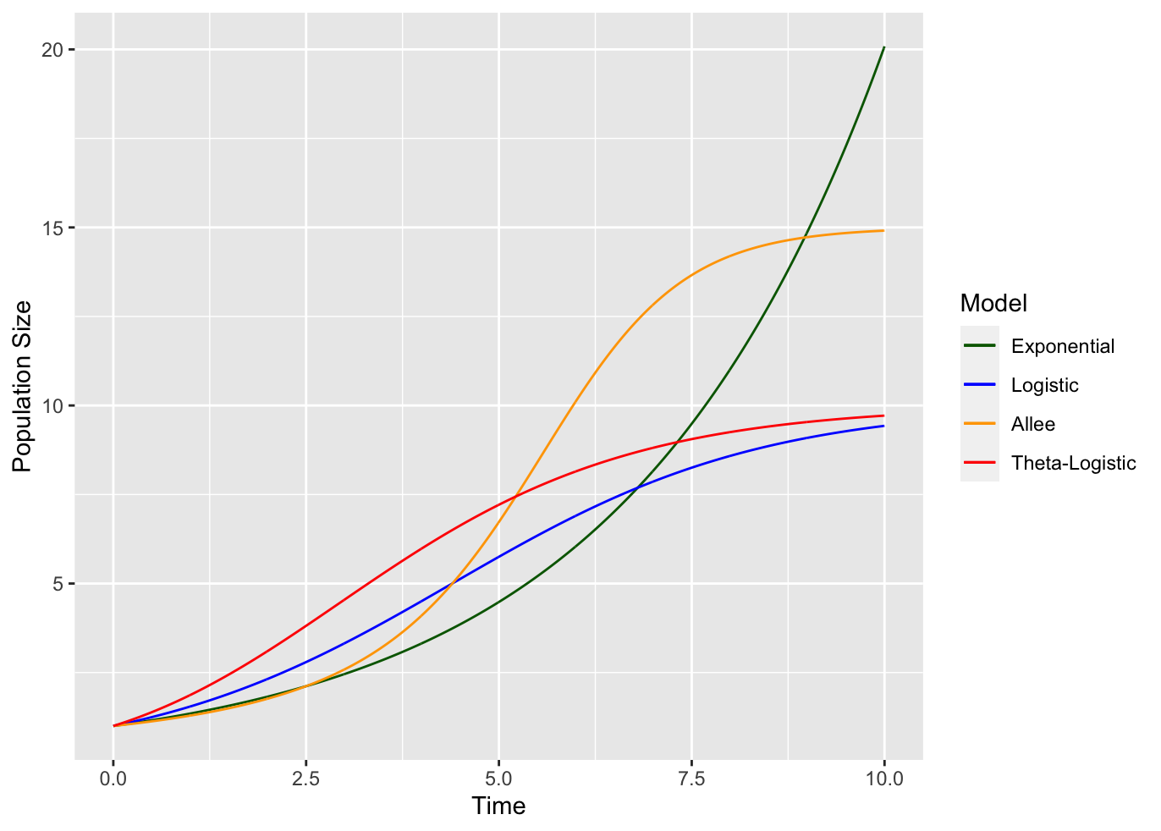

***Figure 8:*** *The numerically integrated growth for the exponential, logistic, Allee model, and Theta-logistic model. All models start with a population size 1. In the exponential model, $r=0.3$. In the Logistic model, $r=0.5$, $k=10$. In the Allee model, $u=2$, $v=5$, $c=0.1$. In the Theta-Logistic model, $r=1$, $k=10$, $θ=0.5$.*

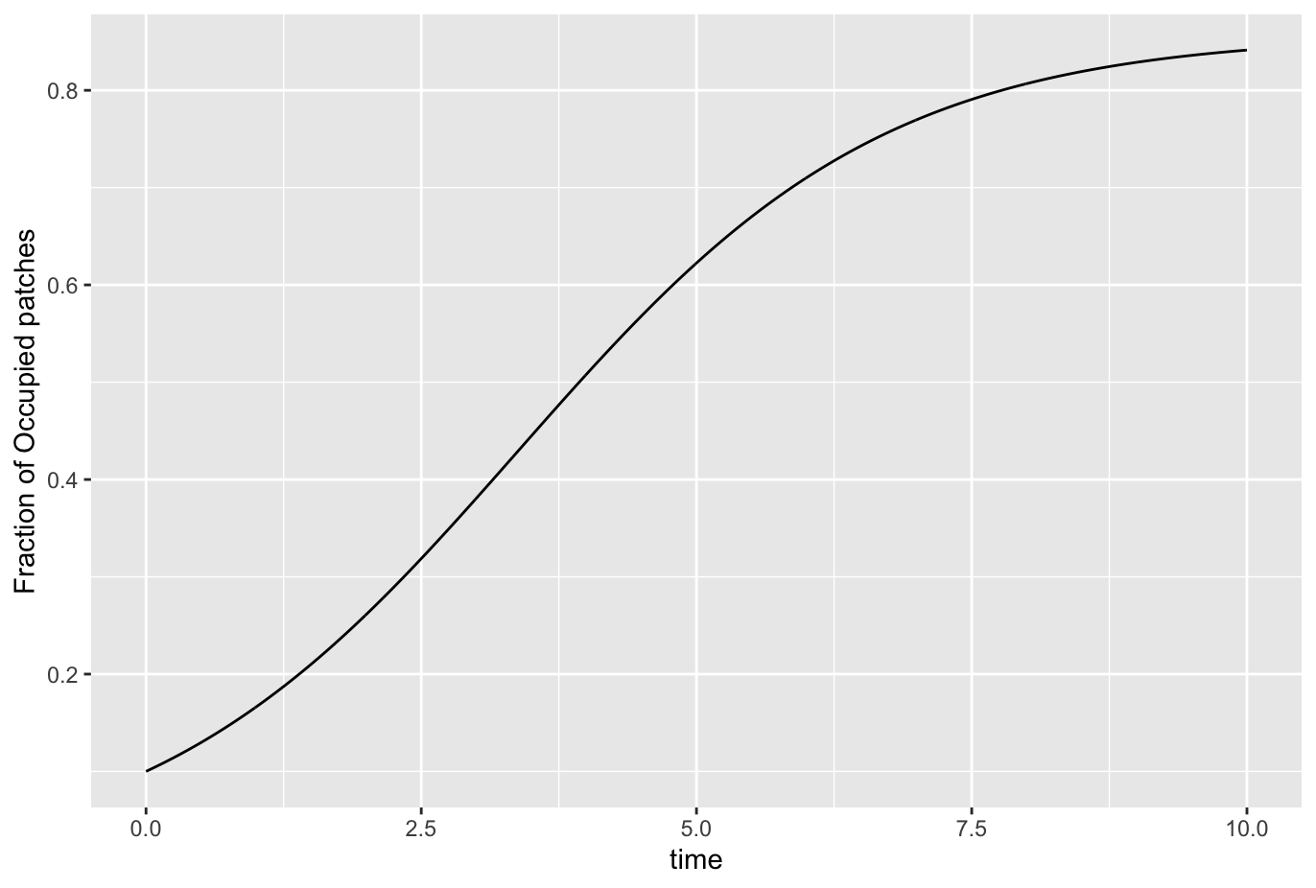

***Figure 9:*** *The growth of an initial population occupying 10% of the habitat in the Levin model with a colonization rate $c=0.7$, and an extinction rate $e=0.1$*